CHAPTER – I
INTRODUCTION

  - Scope of Analysis

- This project focuses on predicting heart attack risk using machine learning models based on patient data. The primary objective is to identify key risk factors such as age, heart rate, smoking, alcohol consumption, and medical history to develop a model that helps in early detection and prevention.

- The study follows a structured data science approach, which includes data preprocessing, exploratory data analysis (EDA), model training, and evaluation. The findings are visualized using a Power BI dashboard, making them easily accessible to medical professionals and decision-makers.

- By analyzing patient data, this project aims to support healthcare professionals in identifying high-risk individuals, promoting preventive measures, and improving overall patient outcomes. The insights from the analysis can also contribute to public health awareness and better lifestyle recommendations.

1.2 Approach of Analysis

- The approach to this analysis follows a structured methodology to ensure accurate and insightful predictions of heart attack risk. The process begins with data collection and preprocessing, where the dataset is cleaned by handling missing values, removing duplicates, and standardizing numerical features. Categorical variables such as smoking status and family history are encoded to facilitate model training.

- Exploratory data analysis (EDA) is conducted to understand data distribution, detect patterns, and identify correlations between variables. Statistical summaries and visualizations such as histograms, scatter plots, and correlation heatmaps help in gaining insights into the relationships between factors like heart rate, age, and heart attack risk.

- The feature selection and engineering phase ensures that only the most relevant attributes contribute to the model. Techniques such as correlation analysis and importance ranking help refine the dataset, improving model efficiency and accuracy.

- In the model development phase, a machine learning algorithm, specifically a Random Forest classifier, is employed to classify individuals based on their likelihood of experiencing a heart attack. Hyperparameter tuning is applied to optimize model performance, enhancing its predictive capabilities. The model is then evaluated using metrics such as accuracy, precision, recall, and a confusion matrix to assess its effectiveness.

CHAPTER – II
GATHERING DATA
2.1 Data Overview
- The heart attack prediction dataset consists of 8,073 records and 17 variables, covering a mix of demographic, lifestyle, and medical history factors that contribute to cardiovascular risk. The dataset is structured with a unique Patient ID for each individual, ensuring that records are identifiable. Key demographic features include Age and Sex, which play a significant role in heart disease risk assessment. The dataset further includes Country and Continent, which may provide geographical insights into variations in heart disease risk. The target variable, Heart Attack Risk, is a binary factor (0 = No Risk, 1 = At Risk), indicating whether a patient is considered high-risk for heart attacks based on their health profile.

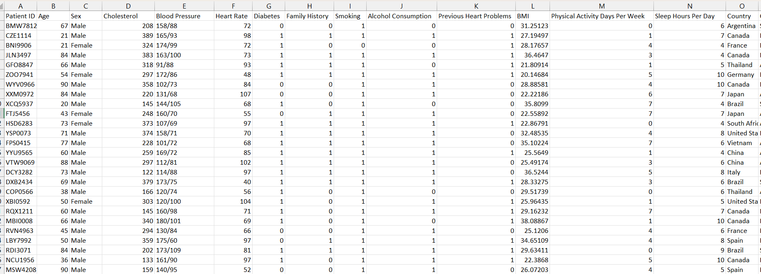

2.2 Data Importing
Load the relevant packages or libraries

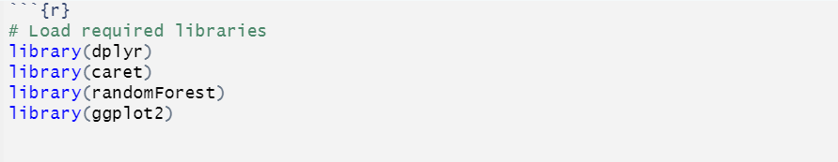

Load the respective dataset

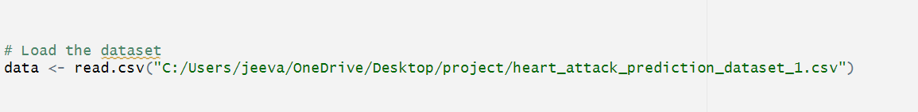

2.3 Data Description
The dataset has contains 8073 rows and 17 columns.
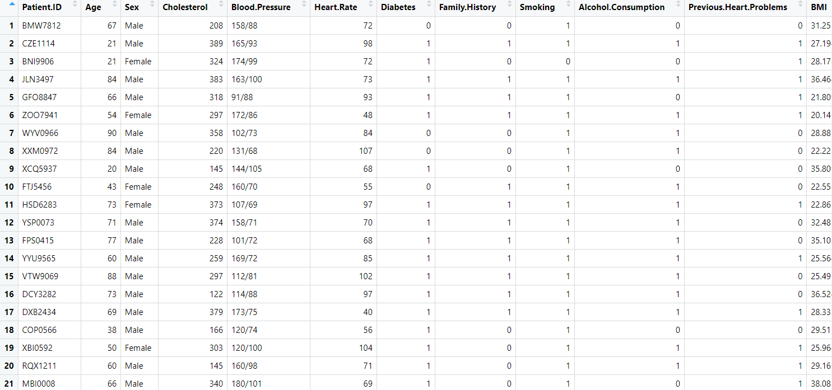

Categorical Variables:
- Smoking Status
Whether the patient is a smoker or non-smoker.
- Family History
Presence of heart disease in immediate family members.
- Alcohol Consumption
Frequency of alcohol intake.
- Previous Heart Problems
History of cardiovascular diseases.

- Gender
Male or Female.
- Geographical Information
Country or region where the patient resides.

Continuous Variables:
- Age
The patient’s age.
- Heart Rate
Resting heart rate measured in beats per minute.
- Cholesterol Levels
Blood cholesterol concentration.
- Blood Pressure
Systolic and diastolic blood pressure readings.
- BMI (Body Mass Index)
Indicator of body fat based on height and weight.

Target Variable:
- Heart Attack Risk
A binary variable indicating whether a patient is at risk of a heart attack (Yes/No). This is the dependent variable that the model aims to predict based on the given predictors.

2.4 Understanding Data
Summary of Dataset
- This module explains the data understading. The dataset consist of different columns. Each and every columns we should find the summary() function.
- This function is used to calculate Average value and determine the maximum minimum and other statistical information in a data frame.
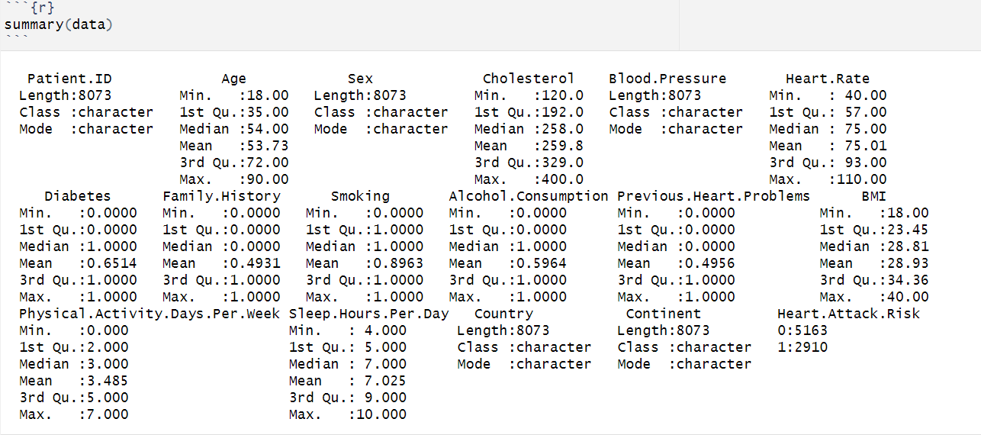

CHAPTER – III
PREPARING AND EXPLORATION DATA

3.1 Checking for missing values
- Missing values (denoted as NA) can cause errors in data analysis, So it is important to detect and handle them properly. Below, I’ll explain different ways to check for missing values in R
Checking the total number of missing values
- Sum(is.na(data)) its counts the total number of TRUE values, i.e., the total number of missing values in the dataset
```{r}
Sum(is.na(data))
```
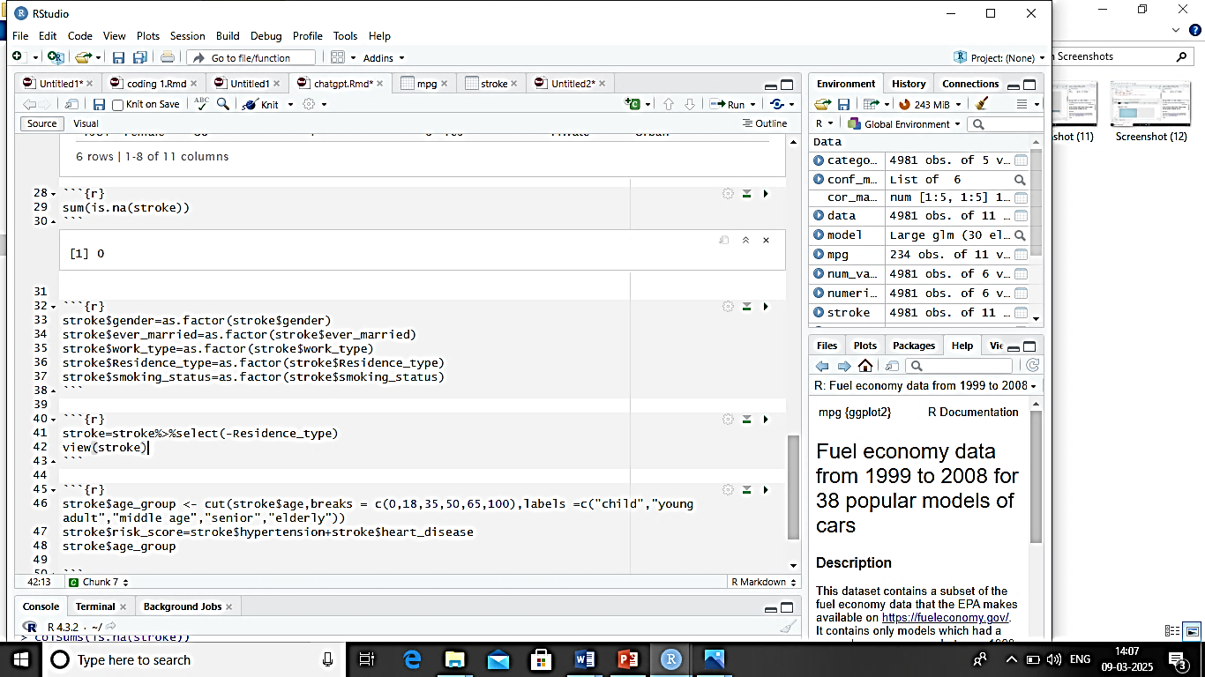
Checking Missing Values in each column
colSums(is.na(data)) its counts the number of missing values for each column.
```{r}
Colsums(sapply(data,is.na))
```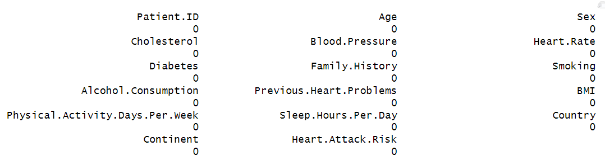

3.2 Convert target variable to factor
- This line of R code is used to convert the Heart.Attack.Risk variable into a factor (categorical) variable if it is stored as a numeric or character type.

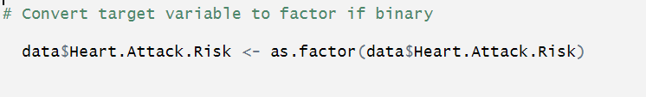

- The function factor is used to encode a vector as a factor (the terms ‘category’ and ‘enumerated type’ are also used for factors).

- If argument ordered is TRUE, the factor levels are assumed to be ordered. For compatibility with S there is also a function ordered.

3.3 Data Exploration
Exploratory Data Analysis (EDA)
- Exploratory Data Analysis (EDA) is an essential step in understanding the dataset before building predictive models. It helps in identifying patterns, detecting anomalies, and understanding relationships among variables.

- Used charts Histogram,Bar,Box,Scatter,Pie

Selected EDA Charts
- Histogram: Age Distribution by Heart Attack Risk
- Box Plot: Cholesterol Levels by Heart Attack Risk
- Bar plot: Smoking vs Heart Attack Risk
- Scatter Plot: BMI vs Age by Heart Attack Risk
- Bar Plot: Physical Activity vs Heart Attack Risk
- Pie chart: Heart Attack Distribution

These are the above listed charts that are statistically meaningful enough to take the project to next level. These charts give meaningful data driven approach for business to give useful insights

Age Distribution by Heart Attack Risk
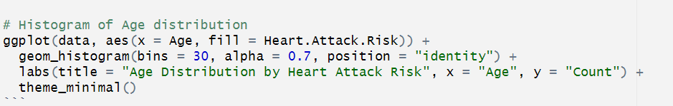

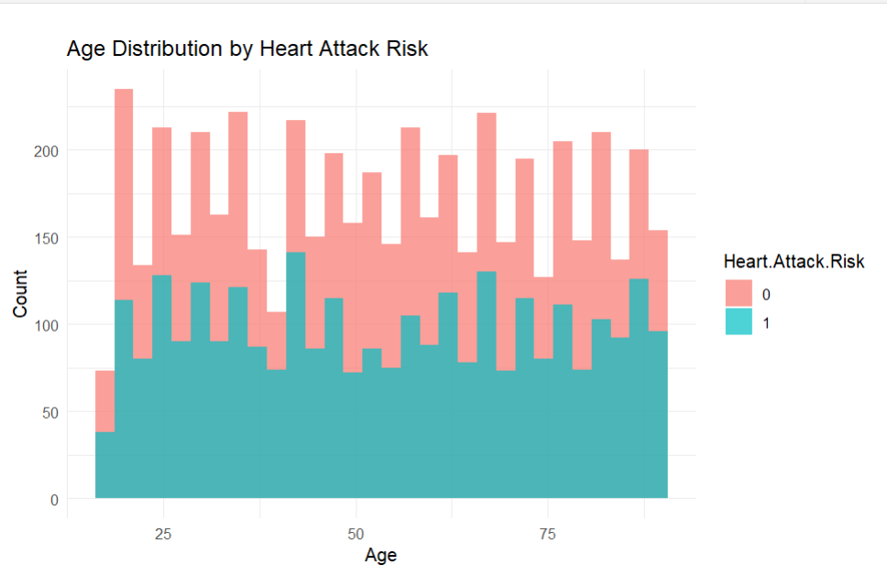

- This histogram is designed to analyze the distribution of patient ages and compare it across different heart attack risk categories. The goal is to identify whether certain age groups are more likely to have a high risk of heart attack.

Cholesterol Levels by Heart Attack Risk
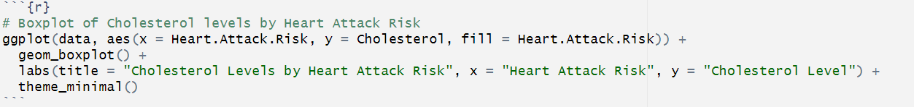

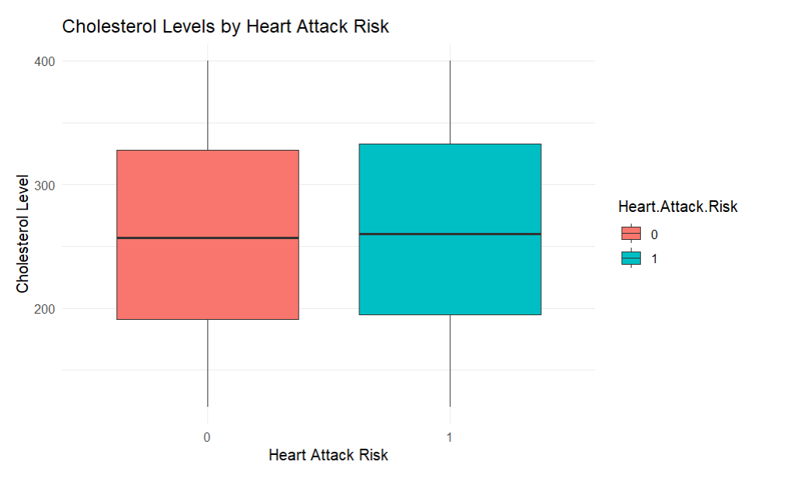

- Boxplot is a powerful visualization tool that helps in understanding the distribution, spread, and variability of data.

- In this case, the boxplot is used to compare cholesterol levels between patients at risk and not at risk for a heart attack.

Smoking vs Heart Attack Risk
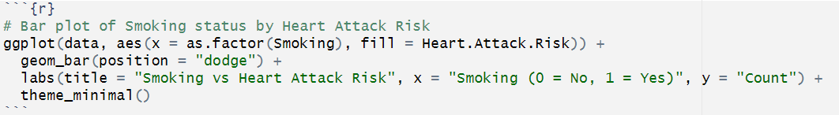

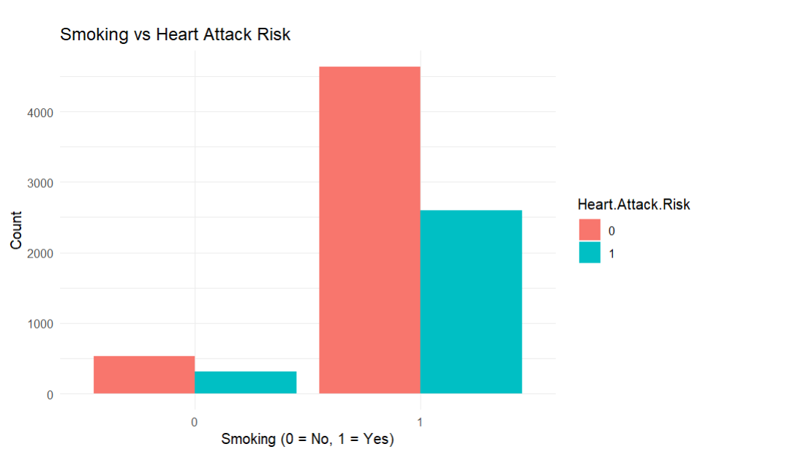
- This bar plot is used to analyze the relationship between smoking status and heart attack risk.

- It helps in determining whether smokers are more likely to be at risk of a heart attack compared to non-smokers.

BMI vs Age by Heart Attack Risk
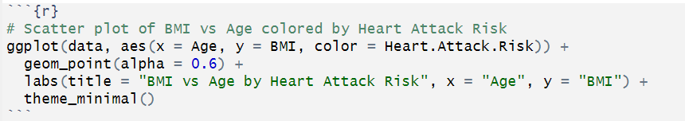
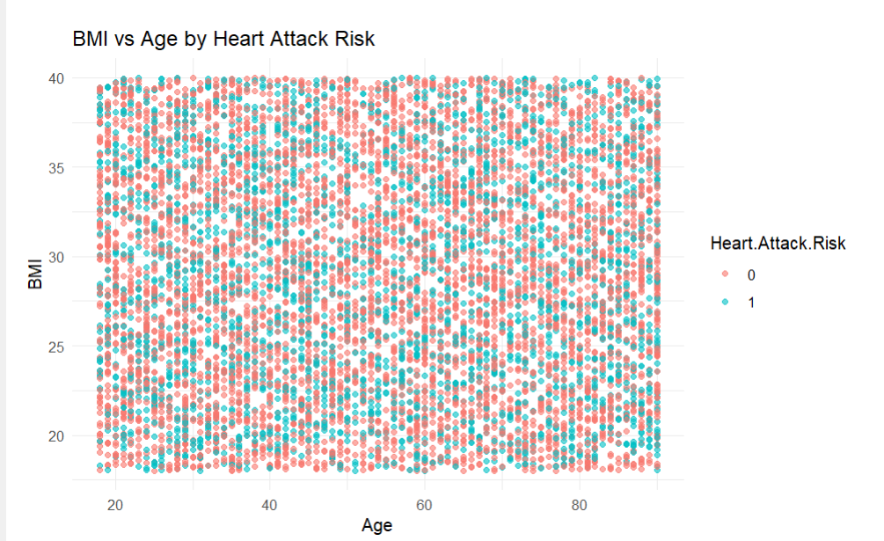
- This scatter plot is used to analyze the relationship between BMI (Body Mass Index) and Age, and how it correlates with heart attack risk.

- The goal is to identify patterns in BMI across different age groups and see whether patients at risk of heart attacks tend to have higher BMI values.

Physical Activity vs Heart Attack Risk
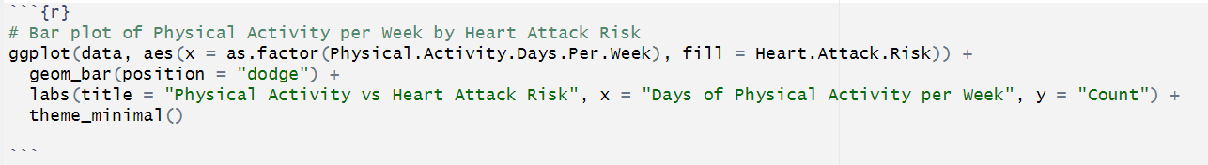
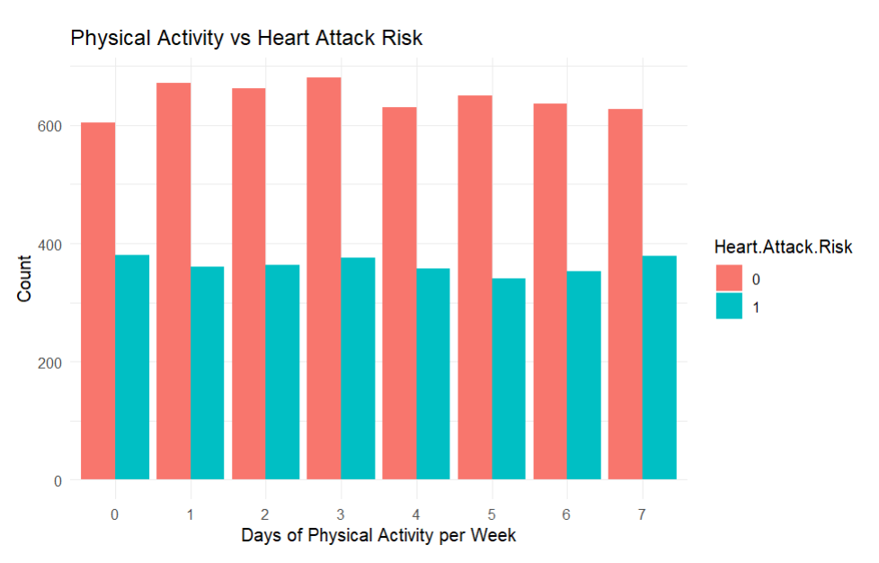
- This bar plot is used to analyze the relationship between physical activity levels (measured as days per week of exercise) and heart attack risk.

- The goal is to determine whether people who engage in more physical activity have a lower or higher likelihood of heart attack risk.

Heart Attack Distribution .
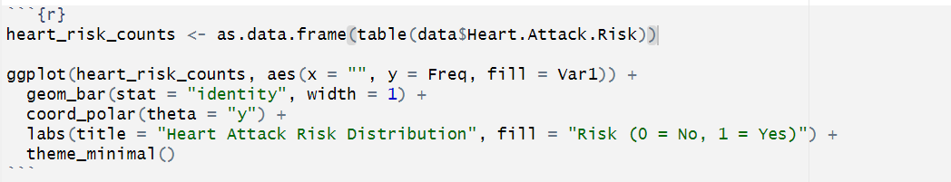
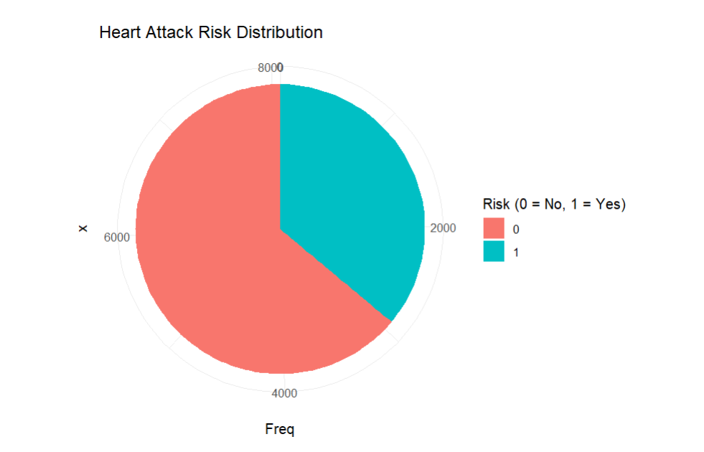
- This pie chart is used to visualize the proportion of patients at risk (1) and not at risk (0) of a heart attack.

- It helps in understanding whether the dataset has a balanced or imbalanced distribution of heart attack risk

CHAPTER-IV
BUSSNIESS INTELLIGENCE WITH DASHBOARD

4.1 DASHBOARD
- A dashboard is an essential tool for visualizing and analysing data in a structured and interactive manner. It provides users with a consolidated view of key metrics, trends, and performance indicators, allowing them to make informed decisions efficiently.

- One of the primary advantages of a dashboard is its ability to present real-time data in a user-friendly format.

- Instead of navigating through multiple spreadsheets or databases, users can access critical insights at a glance. Through data visualization techniques such as charts, graphs, tables, and KPI indicators, dashboards make it easier to interpret complex datasets and identify patterns or anomalies.

Dashboard Tpyes:
- Excel, Power BI, and Tableau offer three types of dashboards. Excel dashboards are best for basic reporting and small datasets.

- Power BI dashboards provide interactive, real-time data analysis with advanced modelling.

- Tableau dashboards excel in high-quality visualizations and deep analytics for large datasets. Each tool serves different data visualization needs.
1. Excel Dashboard
- Uses Pivot Tables, Charts, and Conditional Formatting for analysis.
- Suitable for basic reporting with limited interactivity.
- Can handle small to medium datasets efficiently.
- Lacks real-time data updates and advanced automation.

2. Power BI Dashboard
- Provides interactive and dynamic visualizations.
- Supports real-time data refresh and cloud-based sharing.
- Enables advanced data modeling using DAX.
- Ideal for business intelligence and performance tracking.

3. Tableau Dashboard
- Specializes in high-quality, AI-powered visualizations.
- Offers drag-and-drop features for easy data exploration.
- Handles large datasets efficiently with fast processing.
- Best for deep analytics and predictive insights.

Here, I used Power Bi:
- Power BI is a data visualization tool used to create interactive dashboards. It helps in analyzing trends, tracking performance, and making data-driven decisions.

- With real-time data updates and seamless integration, Power BI simplifies reporting and enhances business insights.

Heart Attack
- This Heart Attack Risk Prediction Analysis Dashboard provides key insights into factors influencing heart attack risk. It highlights the relationship between BMI, physical activity, heart rate, and alcohol consumption across different countries.

- The data suggests that higher BMI and lower physical activity levels are associated with an increased risk of heart attacks. The analysis also shows how alcohol consumption and age impact heart attack risk, with certain groups being more vulnerable.

- Key metrics like average BMI (28.55), physical activity days (957), and blood pressure count (266) provide a deeper understanding of cardiovascular health trends.

Sum of BMI and Count of Continent by Physical Activity Days Per Week

- This line and bar chart illustrates the relationship between physical activity and BMI while also showing the count of different continents in the dataset.

- The blue line represents the sum of BMI, which fluctuates across different physical activity levels. The peaks in the BMI trend indicate that individuals with certain activity levels have significantly higher or lower BMI.

- The bar elements show the count of individuals from different continents, providing insights into regional distribution.

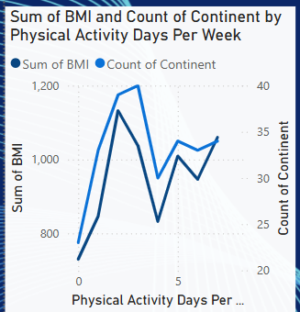

Sum of BMI by Country (Pie Chart)
- This pie chart segments the total BMI by country, offering a comparative view of how BMI is distributed among different nationalities.

- Each segment represents a country, and the size of each slice corresponds to the contribution of that country to the total BMI in the dataset.

- It helps in identifying whether certain regions have a higher prevalence of obesity, which is a crucial factor in heart attack risk.

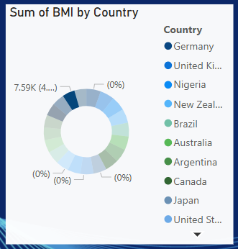

Sum of BMI by Heart Rate
- This line graph visualizes how BMI is distributed across different heart rate values.

- The fluctuations suggest variations in heart rate for individuals with different BMI levels, possibly indicating patterns in obesity and heart health.

- Higher BMI might be associated with higher heart rate variability, which is a known risk factor for cardiovascular issues.

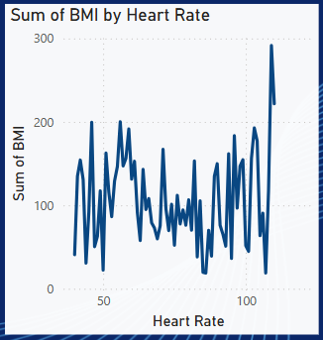

Sum of Heart Attack Risk and Sum of BMI
- This bar chart compares the sum of BMI against heart attack risk levels.

- A significant difference between bars suggests that higher BMI is linked to an increased risk of heart attacks.

- The chart highlights the need to monitor weight management as a preventive measure.

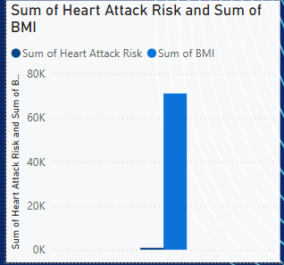

Sum of Heart Attack Risk by Alcohol Consumption and Age
- This waterfall chart breaks down heart attack risk based on alcohol consumption and age groups.

- The different color segments indicate variations in risk levels.

- A higher risk in certain age groups and alcohol consumption patterns might suggest that excessive alcohol intake contributes to cardiovascular issues, particularly among certain demographics.

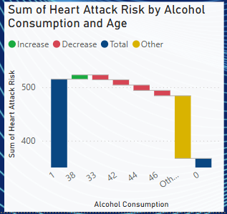

Sum of Heart Attack Risk and Sum of Physical Activity Days Per Week by Country (Pie Chart)
- This pie chart provides insights into how different countries compare in terms of physical activity levels and heart attack risk.

- Countries with lower physical activity might exhibit a higher risk of heart attacks, demonstrating the importance of an active lifestyle.
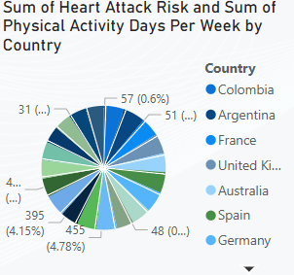
Summary Cards (Numeric Insights on Right Panel)
Sum of Physical Activity Days Per Week (957)
- This represents the total number of physical activity days recorded in the dataset, indicating an overall level of exercise engagement.
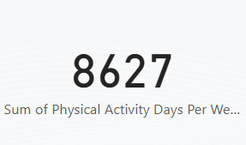

Count of Blood Pressure (266)
- The number of recorded blood pressure measurements, reflecting the dataset’s scope in tracking hypertension-related factors.

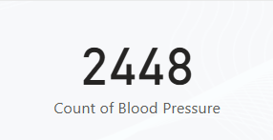

Average BMI (28.55)
- An essential metric highlighting the overall body mass index distribution.

- A BMI above 25 suggests a population leaning toward overweight or obesity, which is a critical risk factor for heart disease.

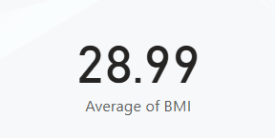

Sex Distribution (Male/Female Checkbox)
- This filter allows the segmentation of data based on gender, helping to analyze whether

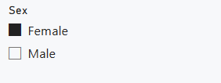
Overview
- This Power BI dashboard focuses on Brain Stroke Prediction and presents various visualization related to stroke risk factors.

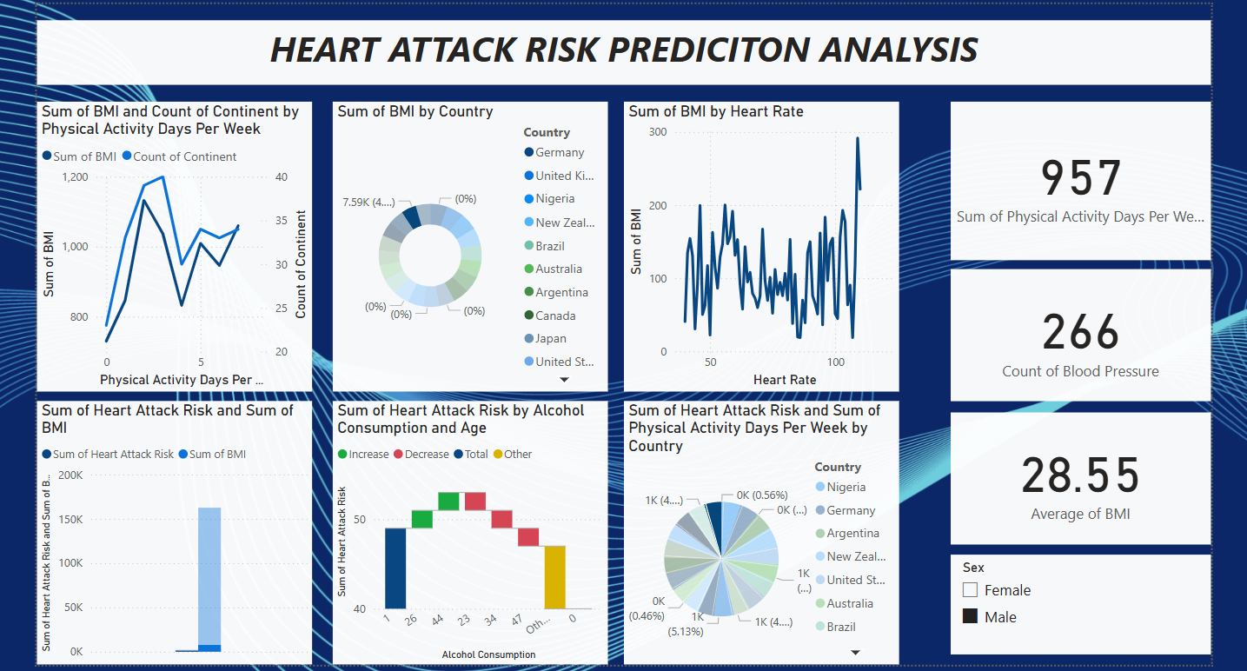

CHAPTER – V
MODEL BUILDING
Machine Learning
- Machine Learning (ML) is a branch of Artificial Intelligence (AI) that enables computers to learn from data and make predictions without being explicitly programmed.
- In this project, ML is used to predict whether a person is affected heart attack or not factors such as Hypertension, Heart disease, Bmi, Average glucose level, smoking status.
Types of Machine Learning Algorithms
Supervised Learning (Used in this project)
- The model learns from labeled data (i.e., historical employee data where we know whether they affect stroke or not).
- Used for classification (Yes/No, Spam/Not Spam) and regression (Predicting salaries, sales, etc.).

Classification Algorithms (Predict Categories: Yes/No, Spam/Not Spam…etc)
- Logistic Regression : Used for binary classification (e.g., stroke prediction).
- Decision Tree :Splits data into branches based on conditions (e.g., medical diagnosis).
- Random Forest : Combines multiple decision trees for better accuracy (e.g., heart attack risk prediction).
- Naïve Bayes: Uses probability to classify data (e.g., email spam filtering).
- Support Vector Machine (SVM) : Finds the best boundary to separate different categories (e.g., face recognition).
- K-Nearest Neighbors (KNN) : Classifies a data point based on its nearest neighbors (e.g., recommendation systems).
- Artificial Neural Networks (ANNs) : Uses layers of neurons for complex predictions (e.g., image recognition)

Regression Algorithms (Predict Continuous Values: Salary, Sales, Stock Prices, etc.)
- Linear Regression : Predicts a continuous value using a straight-line equation (e.g.,house price prediction).
- Polynomial Regression : Extends linear regression for curved relationships (e.g.,sales forecasting).
- Ridge & Lasso Regression : Used for regularization to avoid overfitting (e.g.,predicting medical costs).
- Decision Tree Regression : Splits data into decision-based groups (e.g., stock market prediction).

5.1 Choosing the Model
- I took Random Forest (Classification) for this Project.
- The primary purpose of using Random Forest in this dataset is to develop a reliable model that can predict whether a patient is at risk of a heart attack based on their health and lifestyle attributes.
- The goal of using Random Forest in this dataset is to build a predictive model that can classify whether a patient is at risk of a heart attack based on various health and lifestyle factors.

Predictors and target variable
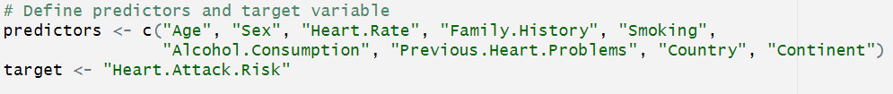
- I Separate into Predictors and Target, Predictors have all the independent variables to be stored in a single variable. Target have only Y variable. It helpful to analyze the outcome.

- The predictors variable is a vector that contains the names of independent variables (features).

- The target variable stores the dependent variable (what we want to predict).

- "Heart Attack Risk" → Represents whether a person is at risk of a heart attack (Yes/No or 1/0).

- The predictor variables (independent features) and the target variable for a heart attack prediction model. The predictors include Age, Sex, Heart Rate, Family History, Smoking, Alcohol Consumption, Previous Heart Problems, Country, and Continent, which are key risk factors.

- The target variable, "Heart Attack Risk", represents whether a person is at risk of a heart attack. These predictors will be used to train a machine learning model to assess heart attack likelihood.

5.2 Training and Testing Dataset
- 80% Training Data and 20% Testing Data
- Training Set: Used to train the random forest classifier model.
- Testing Set: Used to evaluate model performance.
Why 80-20 Spilt?
- 80% Data for Training : Helps the model learn patterns effectively
- 20% Data for Testing :Checks if the model generalizes well on new data
- This is a standard split for classification problems like brain stroke prediction
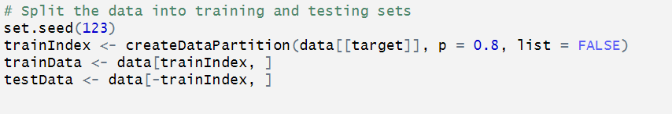
- Sets a random seed to ensure reproducibility. This means every time you run the code, you get the same random split.

- Uses the caret package's create Data Partition() function. data[[target]] The target variable (Heart Attack Risk).

- p = 0.8 is a 80% of the data is used for training, 20% for testing. list = FALSE Returns a vector of row indices instead of a list.

- Selects 80% of the data as the training set. Selects the remaining 20% as the testing set.

Dimension of Train and Test data
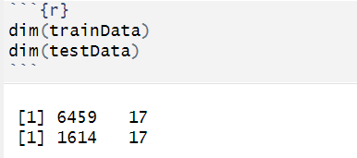

Train Data
```{r}
train_data
```
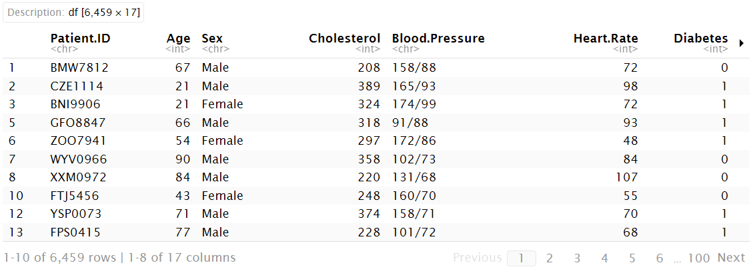

Test Data
```{r}
test_data
```

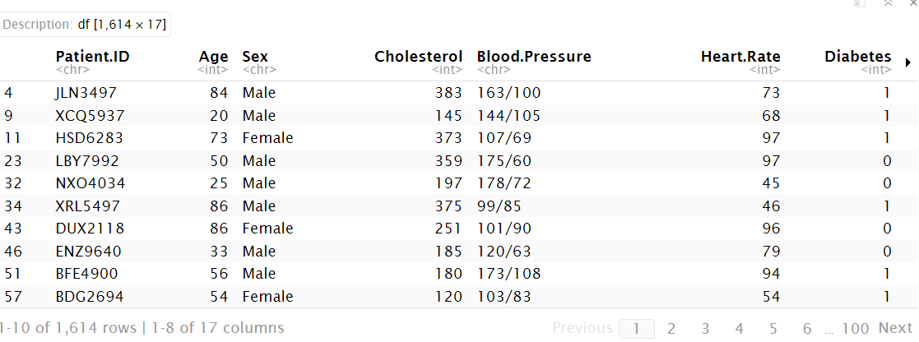

5.3 MODEL
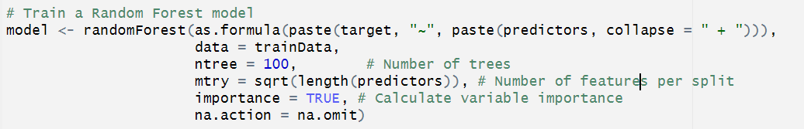
- Target represents the dependent variable (Heart Attack Risk in this case).

- Predictors is a vector of independent variables (e.g., Age, Cholesterol, BMI, Smoking, etc.).

- A higher number of trees generally improves accuracy but increases computation time.

- That rows with missing values are removed before training. Helps avoid errors caused by NA values during model fitting.

- This code builds a Random Forest Classifier to predict heart attack risk based on patient data. The trained model will be able to classify whether a person is at risk (1) or not at risk (0) based on given health attributes.

CHAPTER – VI
EVALUTAE MODEL PERFORMANCE

6.1 Model evaluation
- Model evaluation is the process of assessing how well a machine learning model performs on unseen data. It helps determine whether the model is accurate, reliable, and generalizable to real-world scenarios.

- In Heart Attack Risk prediction, model evaluation ensures that the random forest model correctly identifies patients at risk while minimizing errors.
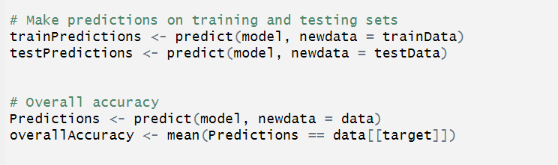
- These predictions are stored in train Predictions and test Predictions, which contain the predicted class labels (0 or 1 for Heart Attack Risk) Which the patient risk or not

- Predict(model, new data = test Data): TO Makes predictions on the test dataset

- The predictions Train Predictions and Test Predictions which the prediction contains the Labels of class indicates (0 or 1) at heart Attack risk
0 indicates the patient at no risk condition
1 indicates the patient at risk condition.

6.2 Overall Accuracy

- Predictions = Target(Y VARIABLE): Compares the predicted values (Predictions) with the actual values Y VARIABLE
- Overall Accuracy stores the final accuracy score, which represents how well the model classifies heart attack risk.

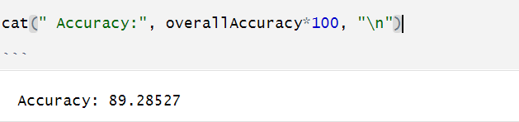

- The accuracy is 89.2 which is well fitted its Good and indicates the model correctly predicts the outcome which it’s not get overfit.

CHAPTER – VII
PREDICTION AND INFERENCE

7.1 Prediction

- This project successfully analysed Heart attack risk prediction which helps to peoples lifestyle to ensure better. To predict the likelihood of a heart attack for a given patient, we would analyze the combination of these risk factors.

- For instance, older patients with high cholesterol, high blood pressure, a history of smoking, and a sedentary lifestyle are more likely to be a high heart attack risk.

- Younger individuals (below 40 years) with no pre-existing conditions. Those with normal cholesterol and blood pressure levels. People who exercise regularly and follow a healthy diet. Non-smokers and individuals with good sleep patterns.

- The prediction of heart attack risk is based on a comprehensive analysis of multiple health and lifestyle factors. Patients with multiple risk factors such as high cholesterol, high blood pressure, smoking, and a sedentary lifestyle are more likely to be at high risk, while those with fewer risk factors are likely to be at low risk.

- This predictive model can be a useful tool in healthcare decision-making, enabling proactive measures for individuals at higher risk.

7.2 Inference

- The analysis of the dataset provides significant insights into the key factors influencing heart attack risk. By understanding the variable importance scores, medical professionals and policymakers can focus on the most influential risk factors, improving patient outcomes through preventive measures.

- The model's predictive capability allows for early identification of individuals at higher risk, enabling proactive interventions through lifestyle modifications, medical consultations, and targeted awareness programs.

- This dataset driven analysis provides a solid foundation for future research and real-world applications in heart attack prevention strategies.

- From a preventive healthcare perspective, individuals with high cholesterol, high blood pressure, and a history of heart problems demonstrated a greater likelihood of heart attacks. Lifestyle factors, including smoking, alcohol consumption, and low physical activity, were also strongly correlated with increased risk.

- The findings emphasize the importance of early intervention, lifestyle modifications, and targeted medical screenings to reduce heart attack incidences.

CHAPTER – VIII
CONCLUSION

The analysis of the dataset using the Random Forest model has provided significant insights into heart attack risk prediction. By leveraging key features such as Age, BMI, Cholesterol, Blood Pressure, Smoking, Physical Activity, and other health indicators, the model effectively identifies patterns associated with increased cardiovascular risk.
The preprocessing steps, including handling missing values, converting categorical variables, and normalizing numerical data, ensured the dataset's quality, leading to more reliable predictions. The model's ability to classify individuals based on their heart attack risk with high accuracy highlights its potential as a valuable tool for early detection and prevention strategies. He predictive insights gained from this model can assist healthcare professionals in making informed decisions, offering personalized recommendations, and improving patient outcomes.

REFERENCES

- V. Lazarov and M. Capota. Churn Prediction. Business Analytics Course. TUM computer science, December 2010. http://home.in.tum.de/~lazarov/files/research/pap ers/churn- prediction.pdf

- Carlo Vercellis, Business Intelligence: Data Mining and Optimization for Decision Making, John Wiley & Sons, Ltd. 2009 ISBN: 978-0-470- 51138-1

- S. Gotovac. “Modeling Data Mining Applications for Prediction of Prepaid Churn in Telecommunication Services,” vol. 51, no. 3, pp. 275-283, 2010

- H. Kim, and C. Yoon, “Determinants of subscriber churn and customer loyalty in the Korean mobile telephony market.” Telecommunications Policy. Vol. 28 No.: PP. 751765, 2004.

- W. Au, C. Chan, and X. Yao, A Novel Evolutionary Data Mining Algorithm with Applications to Churn Prediction, IEEE transactions on evolutionary computation, 7, 6, 532-545, 2003.

- R. Behara, W. Fisher, and J. Lemmink, Modelling and Evaluating Service Quality Measurement Using Neural Networks, International journal of operations and production management, 22, 10, 1162-1185, 2002.

